Smart Hydroponic Farming Using Internet of Things

Software Requirements Specification
<Arduino IDE 1.8.16>
<Blynk IOT Platform>

Team Members:
Abhinav Bellamkonda
Vamsidhar Reddy Police
Nithin Reddy Khumbam
Saivivek Reddy Kusukuntla
Gopi Krishna Kandimalla
Jawahar Reddy Nomula

Submitted in partial fulfilment
Of the requirements of
CSIS 44-692 Graduate Directed Project II
Table of Contents

Table of Contents

- Introduction
  - Purpose
  - Scope
  - Definitions, Acronyms, and Abbreviations
  - References
  - Overview
- General Description
  - Product Perspective
  - Product Functions
  - User Characteristics
  - General Constraints
- Specific Requirements
  - External Interface Requirements
    - User Interfaces
    - Hardware Interfaces
    - Software Interfaces
    - Communications Interface
  - Functional Requirements
  - Methods
  - Non-Functional Requirements
3.4.1. Performance
3.4.2. Reliability
3.4.3. Availability
3.4.4. Security
3.4.5. Portability
3.4.6 Design Constraints
  - Prototype
- Design
4.1. Block diagram
4.2. GUI
- Analysis Models
5.1. Flow Diagram

- INTRODUCTION:

Natural sunlight is widely recognized as the best source for plant growth and development. When the winter months hit, some plants may not receive enough light and die due to lack of maintenance. To promote faster or balanced growth. We wish to use the hydroponics method, which enables us to provide plants the necessary nutrients in an artificial environment utilizing red and blue LED lights that facilitate photosynthesis in plants. These techniques were interfaced with IoT for controlling the system via the internet. The proposed system includes a variety of sensors such as pH sensor to monitor the pH level inside the water, DHT11 Temperature sensor to detect the temperature and Humidity of the Environment, DS18B20 to detect the water temperature. This system also consists of the relay which is used for controlling the water pump to maintain water level inside the tank and HCSR04 sensor to detect the water level inside the tank. The microcontroller that serves as the heart of the system is ESP32. To monitor and control the sensor readings Blynk IoT application is used.

1.1 Purpose:
There are many reasons that plants die that may include lack of sunlight or maintenance. Growing plants in soil uses harmful pesticides, fertilizers, and other toxic farm chemicals to grow the crop as quickly as possible and get a higher yield than was expected. It is also possible to contaminate fresh water, marine habitats, air, and soil if we proceed in this manner.

Using Hydroponic Farming we can eliminate all the possibilities that plants may die. So, we provide artificial sunlight by deploying LED’s and avoid contamination of soil as we are not using any soil in Hydroponic Farming. Plants are directly dumped in the water. The main objective of this project is to maintain the plants in their natural state by monitoring the factors that increase plant life.

1.2 Scope:

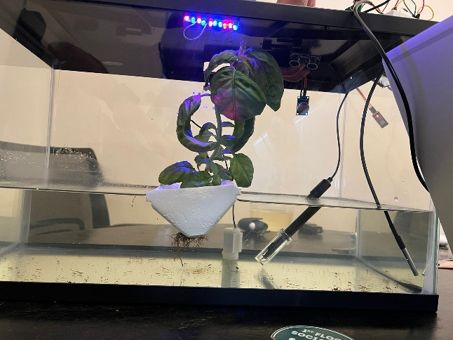

Using Hydroponic farming we can avoid contamination of soil and avoid wastage of water. As the plant grows in the soil the roots of the plants may not absorb proper nutrients. But using Hydroponic farming the plant roots are directly dipped in the water as roots absorb sufficient nutrients, we can expect the faster and stable growth of the plant. Using Hydroponics technique integrated with IoT we can continuously monitor and track the status of the environment variables of the plants and automate the system to maintain the proper environment conditions of the plant

  - Definitions, Acronyms, and Abbreviations:
Arduino IDE: The Arduino Software, often known as the Arduino Integrated Development Environment (IDE) that has text editor for writing code.
Esp32: ESP32 is a microcontroller, an improved version of the ESP8266, supports Wi-Fi in addition to Bluetooth and BLE (Bluetooth Low Energy).
DHT 11: It is a digital humidity temperature sensor consists of capacitive humidity sensing element and a thermistor for sensing temperature.
DS18B20: The DS18B20 is a digital thermometer that can provide 9-bit to 12-bit resolution and can measure temperatures from -55°C to +125°C inside water.
PH sensor: A pH sensor helps to measure the acidity or alkalinity of the water with a value between 0-14.
MQ135: It is an air quality sensor for detecting a wide range of gases, including NH3, NOx, alcohol, smoke, and CO2.
HCSR04: An ultrasonic sensor is an electronic device that measures the distance of a target object by emitting ultrasonic sound waves.

1.4 References:
[1] D. Saraswathi, P. Manibharathy, R. Gokulnath, E. Sureshkumar, & K. Karthikeyan. (2018a, November 22). Automation of Hydroponics Green House Farming using IOT. IEEE Xplore. https://ieeexplore.ieee.org/abstract/document/8541251

[2] Md AshifuddinMondal, & Zeenat Rehena. (2018, August 23). IoT based intelligent agriculture field monitoring system. IEEE Xplore. https://ieeexplore.ieee.org/document/8442535
[3] Ram Krishna Jha, Santosh Kumar, Kireet Joshi, & Rajneesh Pandey. (2018b, April 23). Field monitoring using IoT in agriculture. IEEE Xplore. https://ieeexplore.ieee.org/document/8342777
[4] V, S. (2021). Internet of Things (IoT) based Smart Agriculture in India: An Overview.Journal of ISMAC, 3(1), 1–15. https://doi.org/10.36548/jismac.2021.1.001
[5] Somchoke Ruengittinun, Sitthidech Phongsamsuan, & Phasawut Sureeratanakorn. (2017b, October 19). Applied internet of thing for smart hydroponic farming ecosystem (HFE). IEEE Xplore. https://ieeexplore.ieee.org/abstract/document/8074148
[6] Padma Nyoman Crisnapati, I Nyoman Kusuma Wardana, I Komang Agus Ady Aryanto , & Agus Hermawan. (2017, October 30). Hommons: Hydroponic management and monitoring system for an IOT based NFT farm using web technology. IEEE Xplore. https://ieeexplore.ieee.org/abstract/document/8089268

[7] P Rajalakshmi, & S. Devi Mahalakshmi. (2016, November 3). IOT based crop-field monitoring and irrigation automation. IEEE Xplore. https://ieeexplore.ieee.org/document/7726900
[8] Mahesh S. Gour; Vittal Reddy; Vamsi M.; Sridhar N.; Vishuvardhan; V. Tarak Ram. IoT based Farming Techniques in Indoor Environment: A Brief Survey. (n.d.). IEEE Xplore. Retrieved September 7, 2022, from https://ieeexplore.ieee.org/abstract/document/9137950
[9] Vesperman, S. P. L. M. S. J. M. (2019, November). Smart plant life monitoring system. IEEE Xplore. https://ieeexplore.ieee.org/abstract/document/8907989
[10] Shruti A Jaishetty, & Rekha Patil. (2016b). Iot sensor network based approach for agricultural field monitoring and control. International Journal of Research in Engineering and Technology, 05(06), 45–48.

  - Overview:
The Smart Hydroponic Farming Using Internet of Things includes a variety of sensors such as pH sensor to monitor the pH level inside the water, DHT11 Temperature sensor to detect the temperature and Humidity of the Environment, DS18B20 to detect the water temperature. This system also consists of the relay which is used for controlling the water pump to maintain water level inside the tank and HCSR04 sensor to detect the water level inside the tank. The microcontroller that serves as the heart of the system is ESP32. To monitor and control the sensor readings Blynk IoT application is used.

- General Description
  - Product Perspective:
Arduino IDE 2.0.2 has some bugs where interfacing with some sensors leads to fatal error cases. So, Arduino IDE 1.8.16 is used and compatible for this project. Arduino IDE 1.8.16 is used as a text editor coding and Blynk IOT 2.0 is used for monitoring and sending notification alerts to the user
  - Product Functions:
The system begins to read the pH, temperature, liquid solution temperature, and tank water level readings. When the threshold value is exceeded, Blynk IoT sends the user a notification alert or displays the data. If pH value >7.5 or pH <5.5, water temperature > 70 or water temperature < 50, temperature> 30c, water level >15cm, Notification alerts are sent to the user. According to the input of pH, water temperature, and water level inside the tank, the rules are set to manage the motor condition.

  - User Characteristics
As Automation is done to circulate the water flow inside the tank that contains the plant. We can turn on/off the motor state of the fan when unwanted gases release inside the tank.
  - General Constraints

- Specific Requirements

  - External Interface Requirements:
Esp32 is not directly available inside the boards. So, an external URL must be added in the Additional Boards Manager URLs of Esp32 from GitHub.
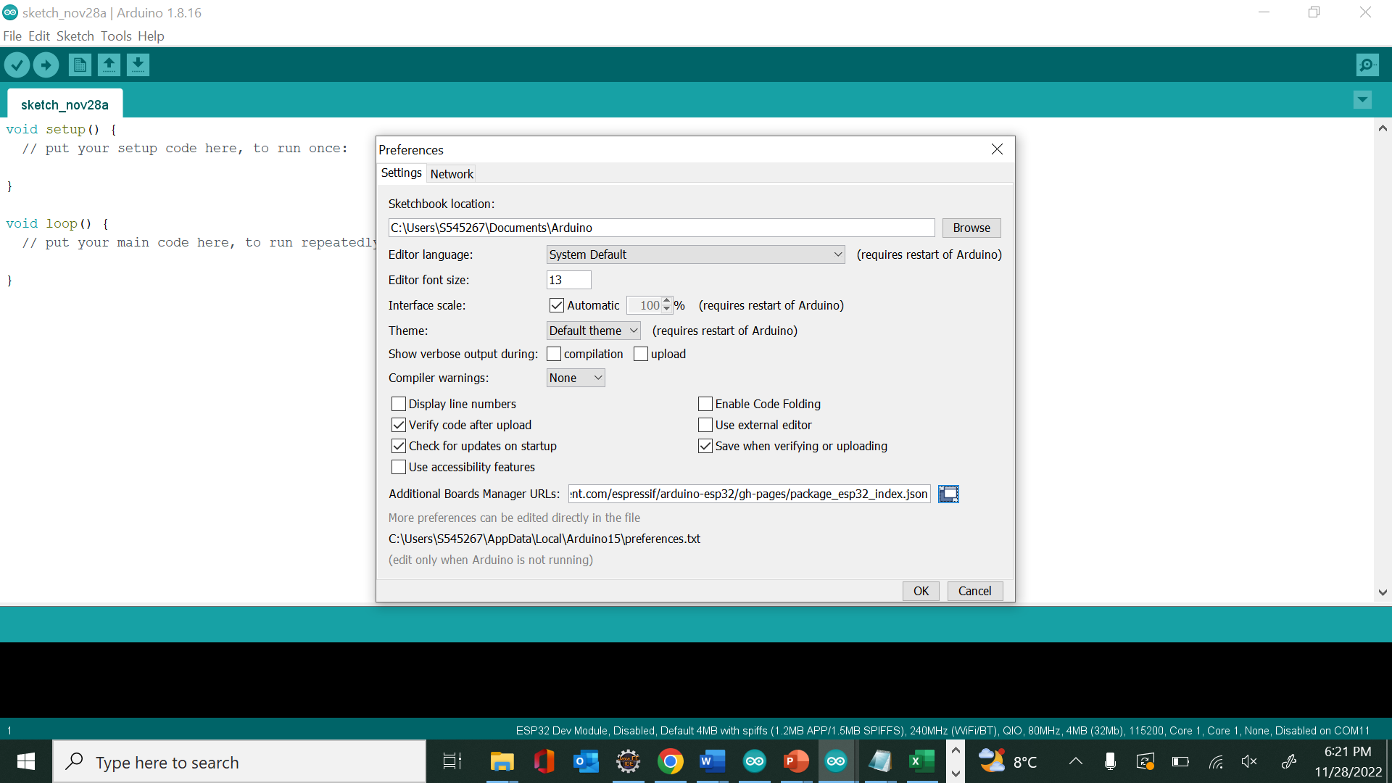

    - User Interfaces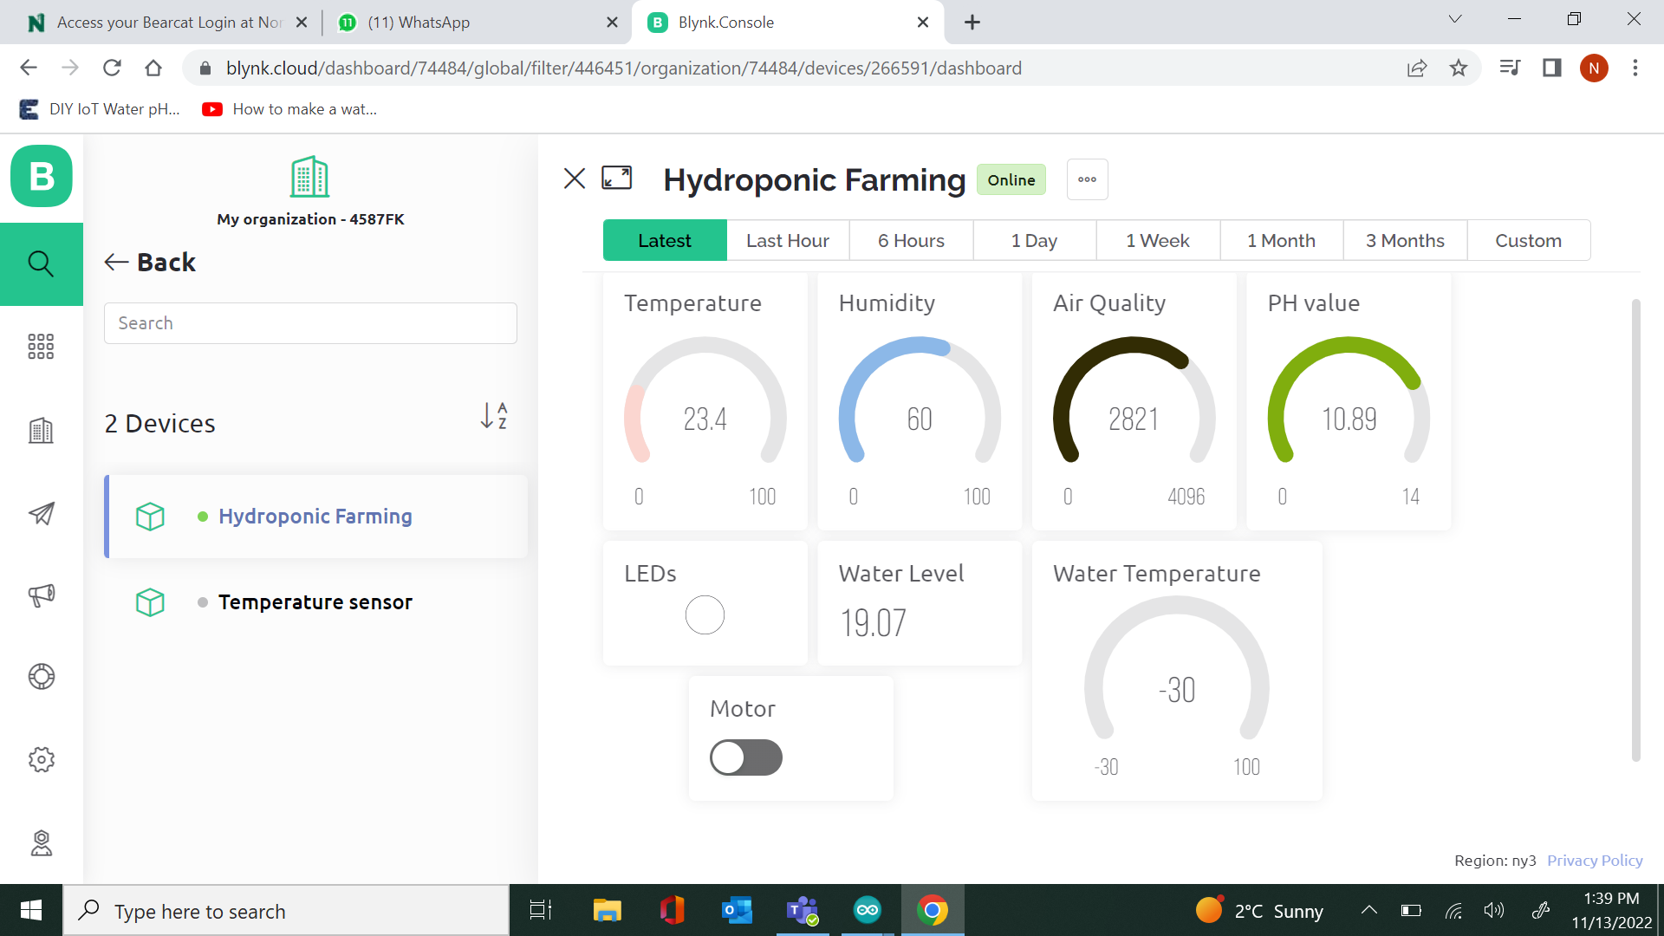

    - Hardware Interfaces
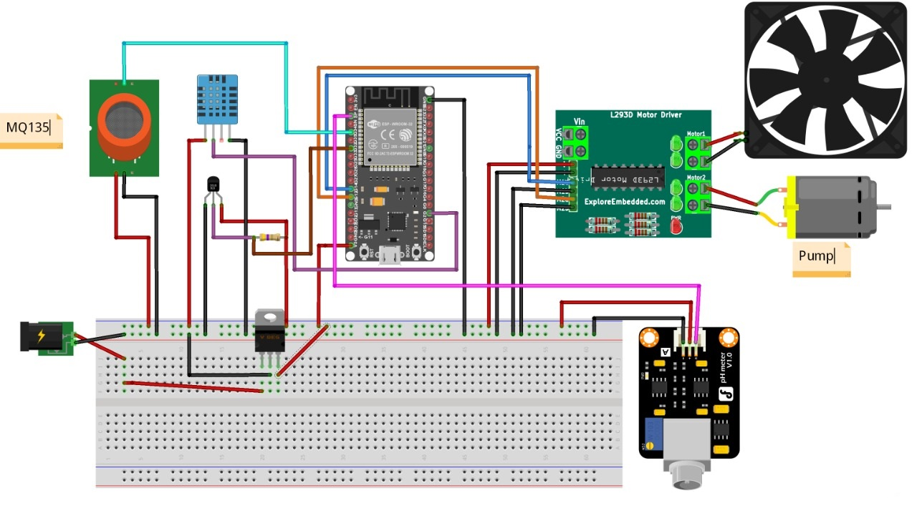
Most of the sensors work on low voltage supply which is 3.3 v except the pH sensor which needs minimum of 9v supply. DS18B20 must be connected to a 4.7k ohm resistor for the accurate reading. Submersible pump and DC motor has to be supplied with a 12v supply.

    - Software Interfaces
:
- Interface
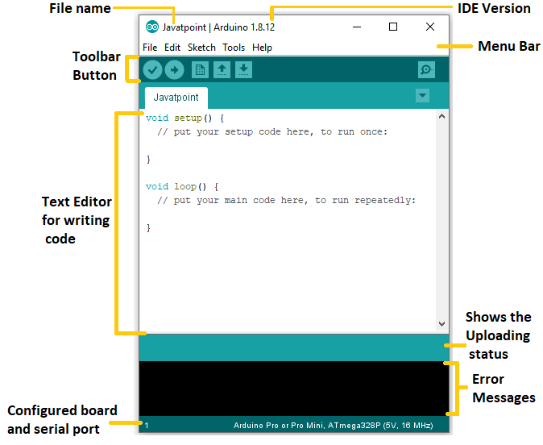

- Minimum Code to be dumped into the microcontroller:
- In setup we initialize pins and pin modes to be used
- In loop, we write the actual logic to be implemented by microcontroller
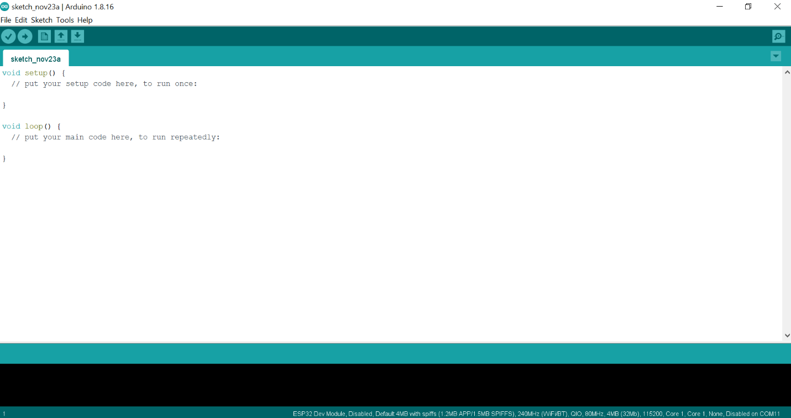

- Select the board that you want to use:
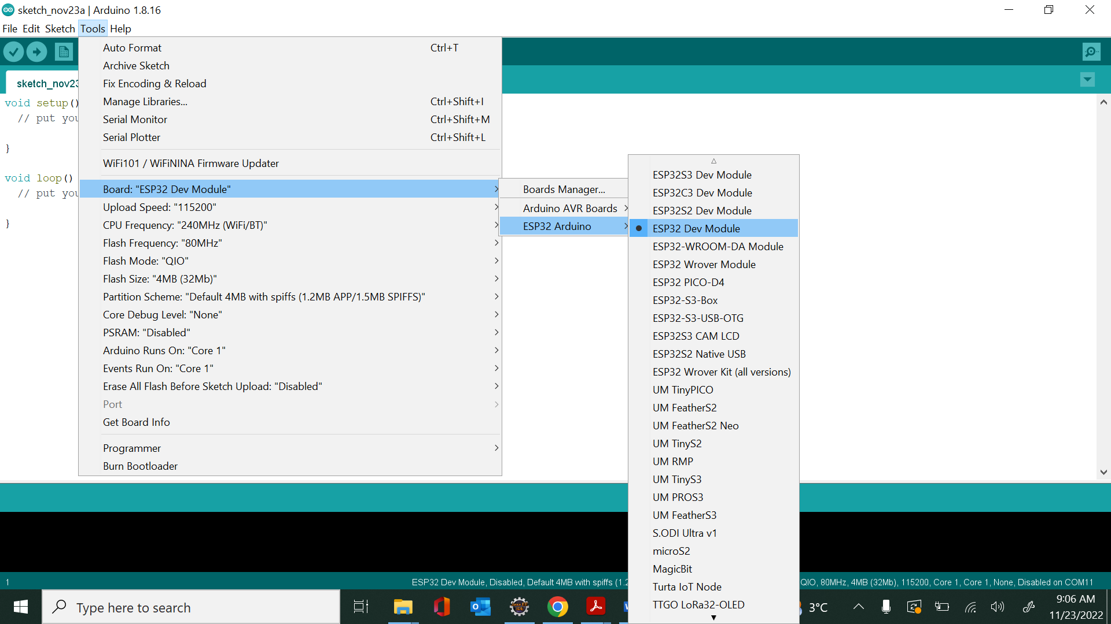

- Select the serial port that you want to use to dump the code to the microcontroller using USB cable for Esp32:
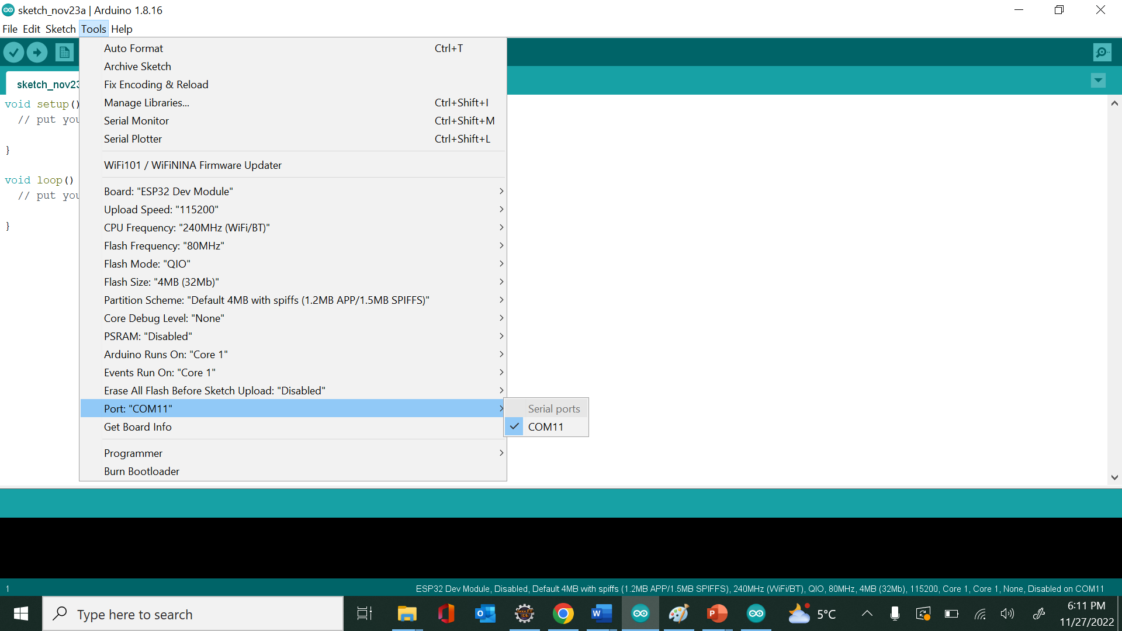

    - Communications Interface:
- Initially create a template.
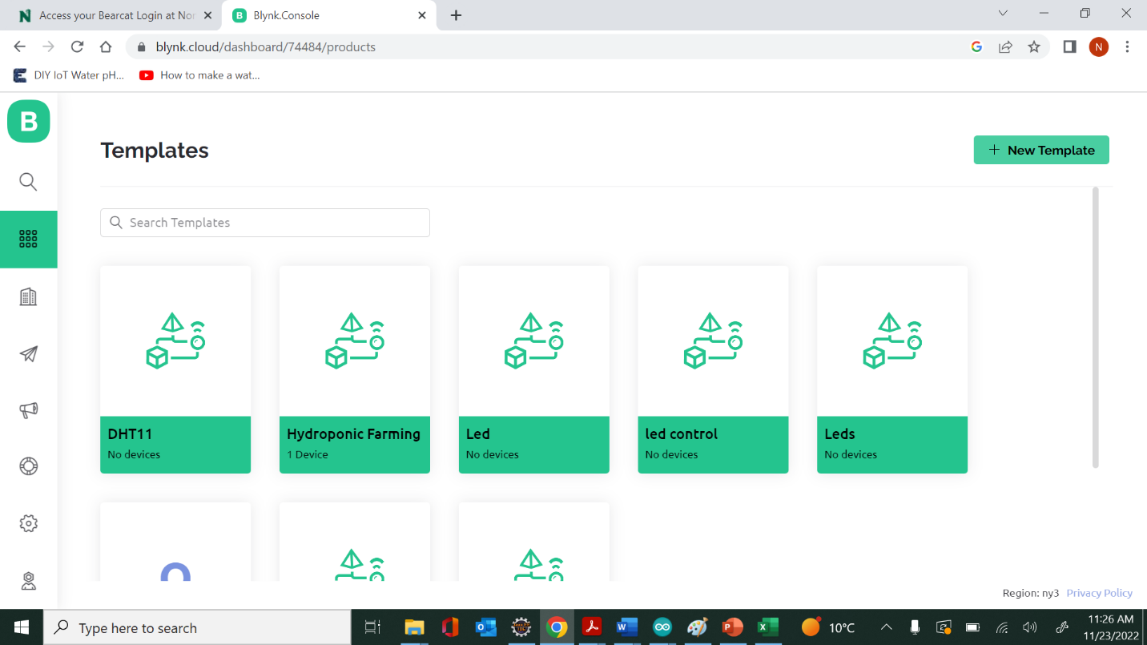
- Give a name for the template and select the microcontroller that you are using in the project.
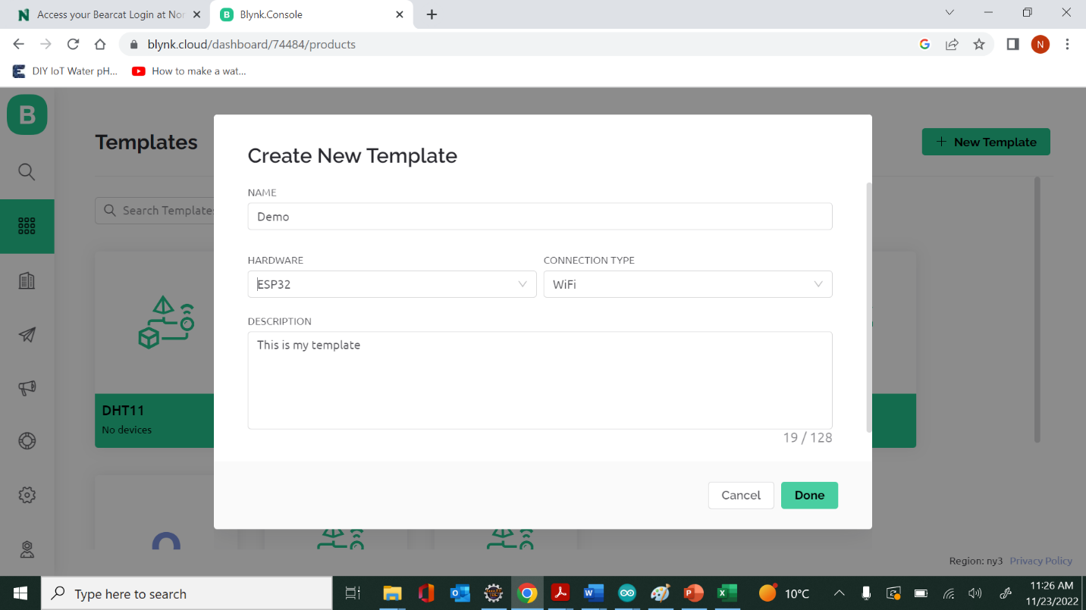

- Create Datastreams by selecting virtual pins.
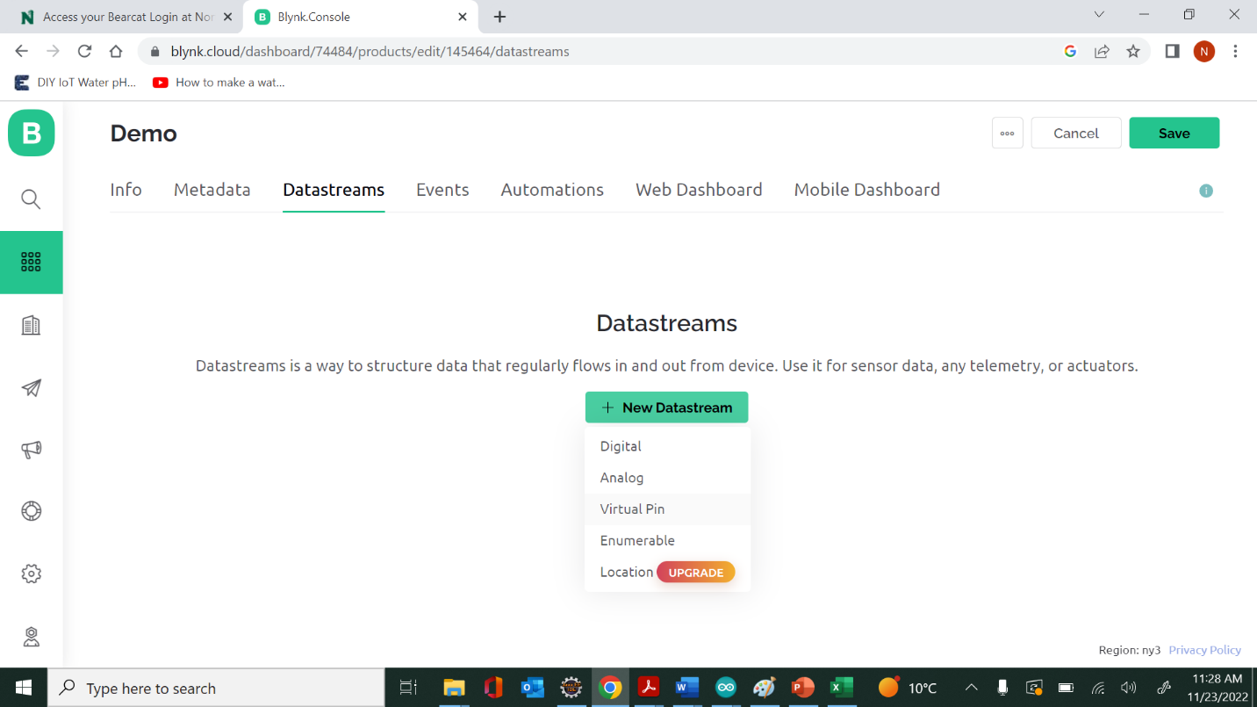
- In virtual pin give the name, datatype and give a range for the sensor reading and click create.
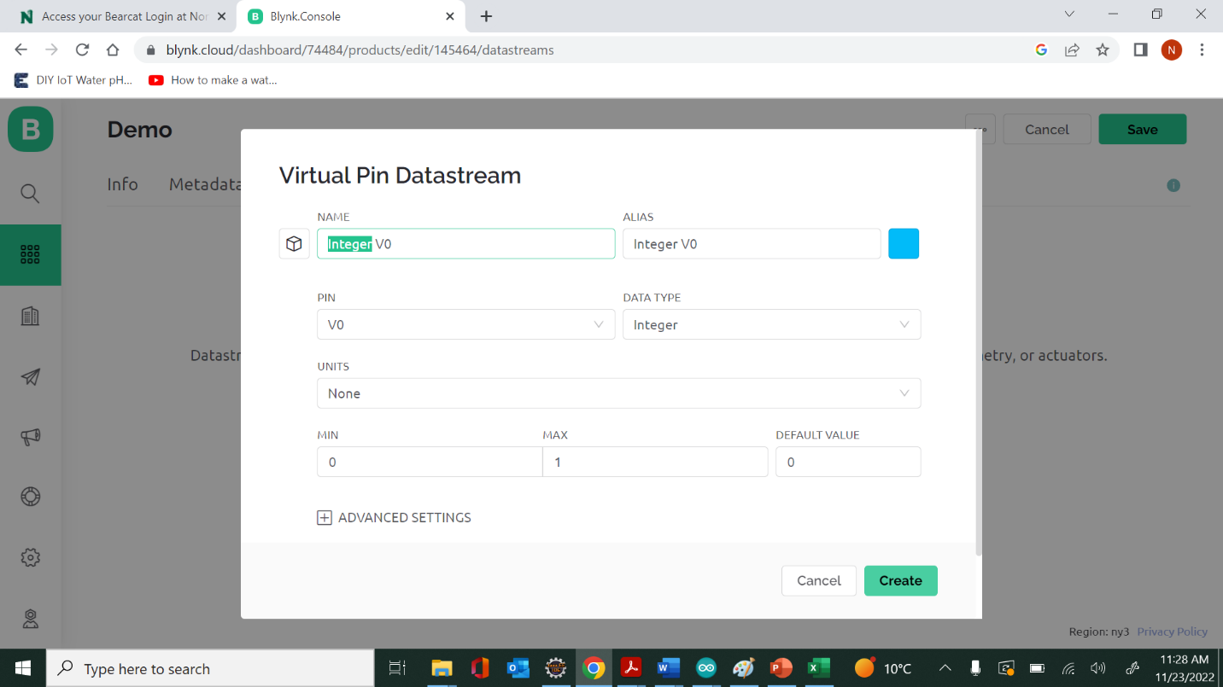

- Now go to the web Dashboard and drag and drop the widgets that you want to use to display for the sensor and select the virtual pin that you want to use and click save.
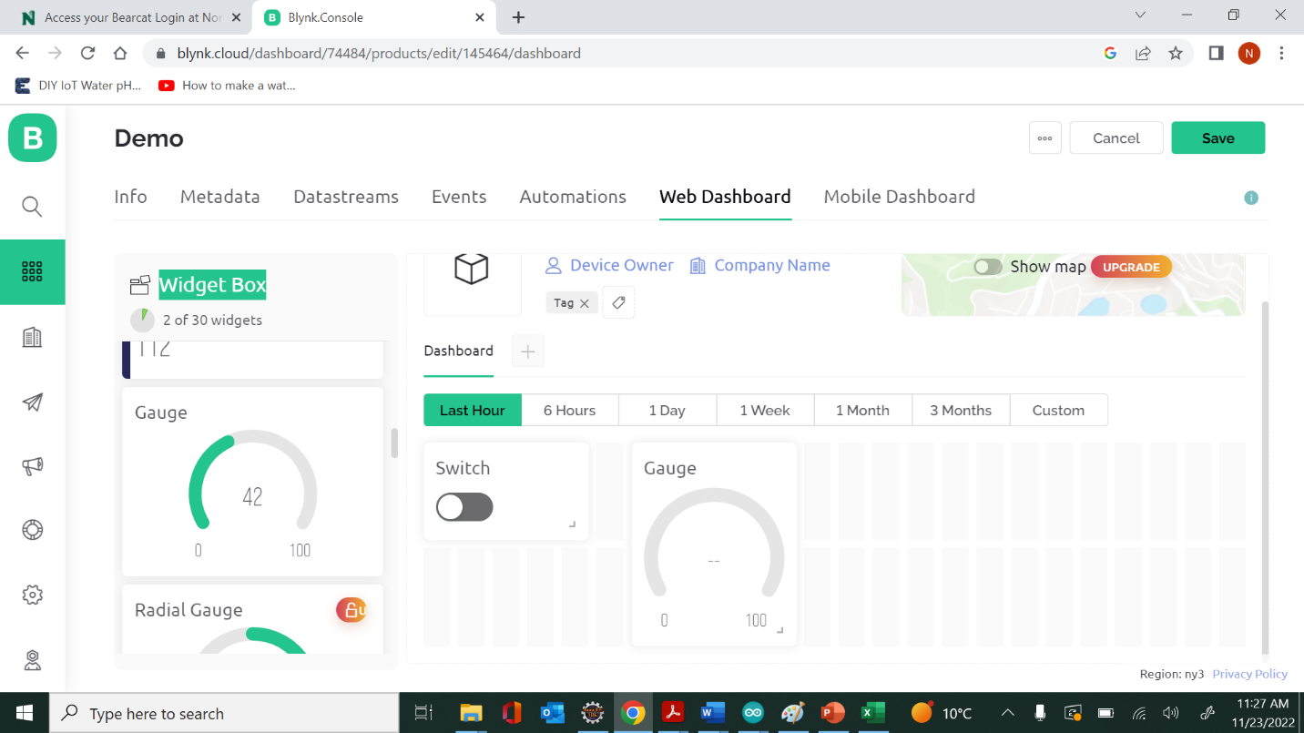

- Now create a new device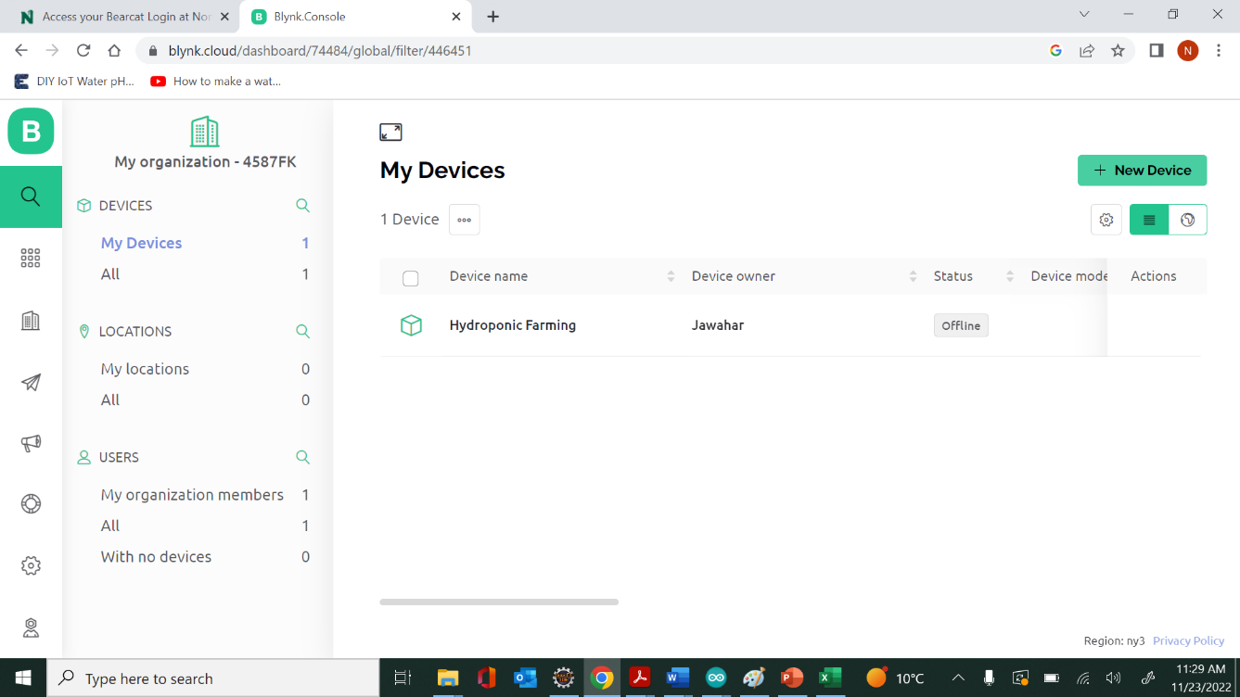
- Create a new device from a template that you have created.
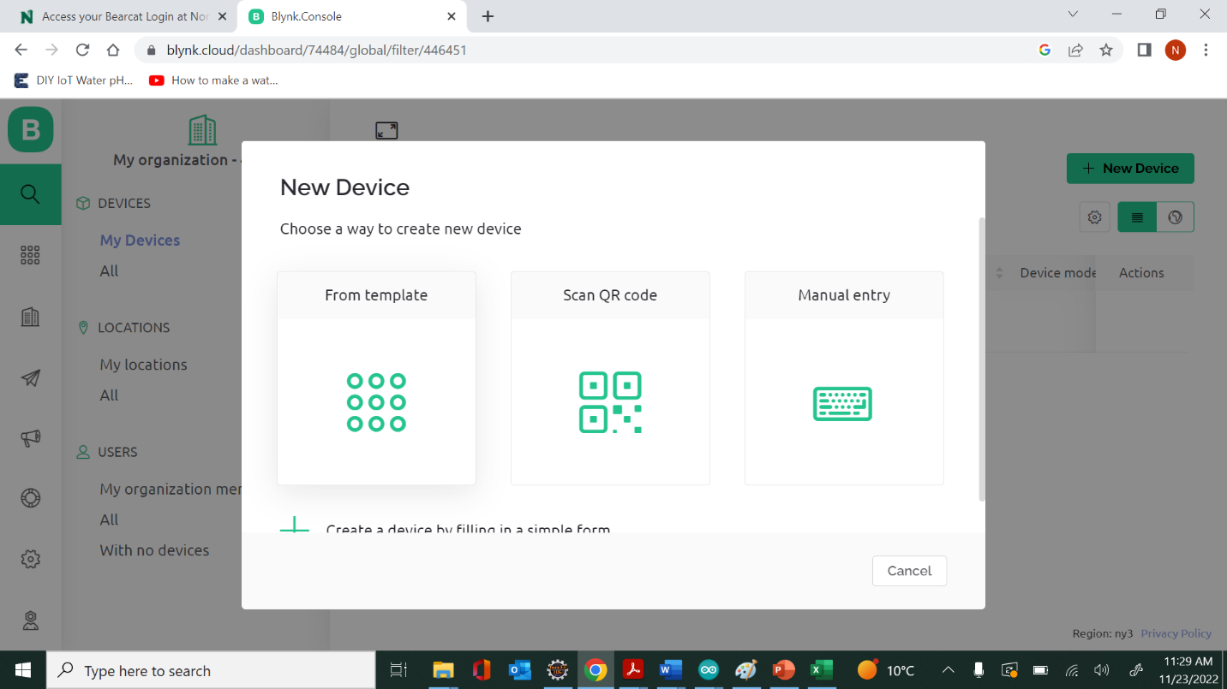

- Select the template and give the name for the device
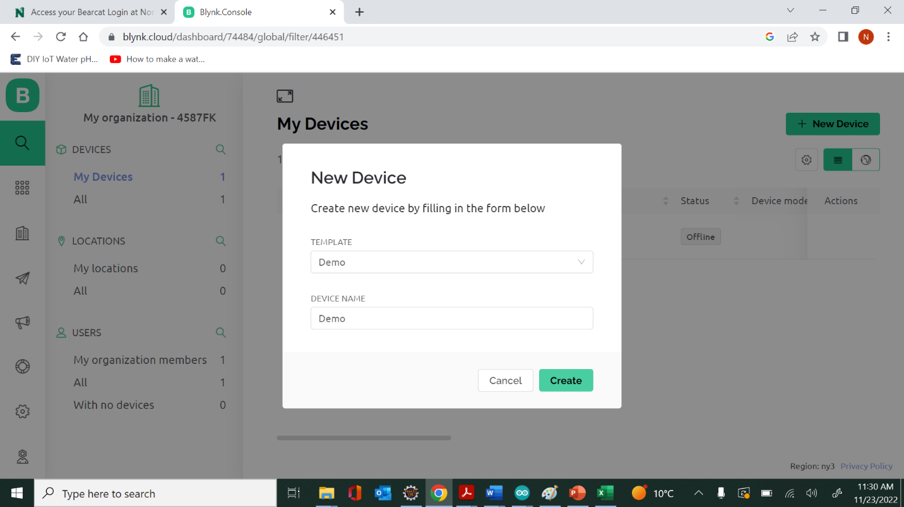

- After creating device, Auth Token is generated now that part of the code has to be used on the top of our code on Arduino IDE.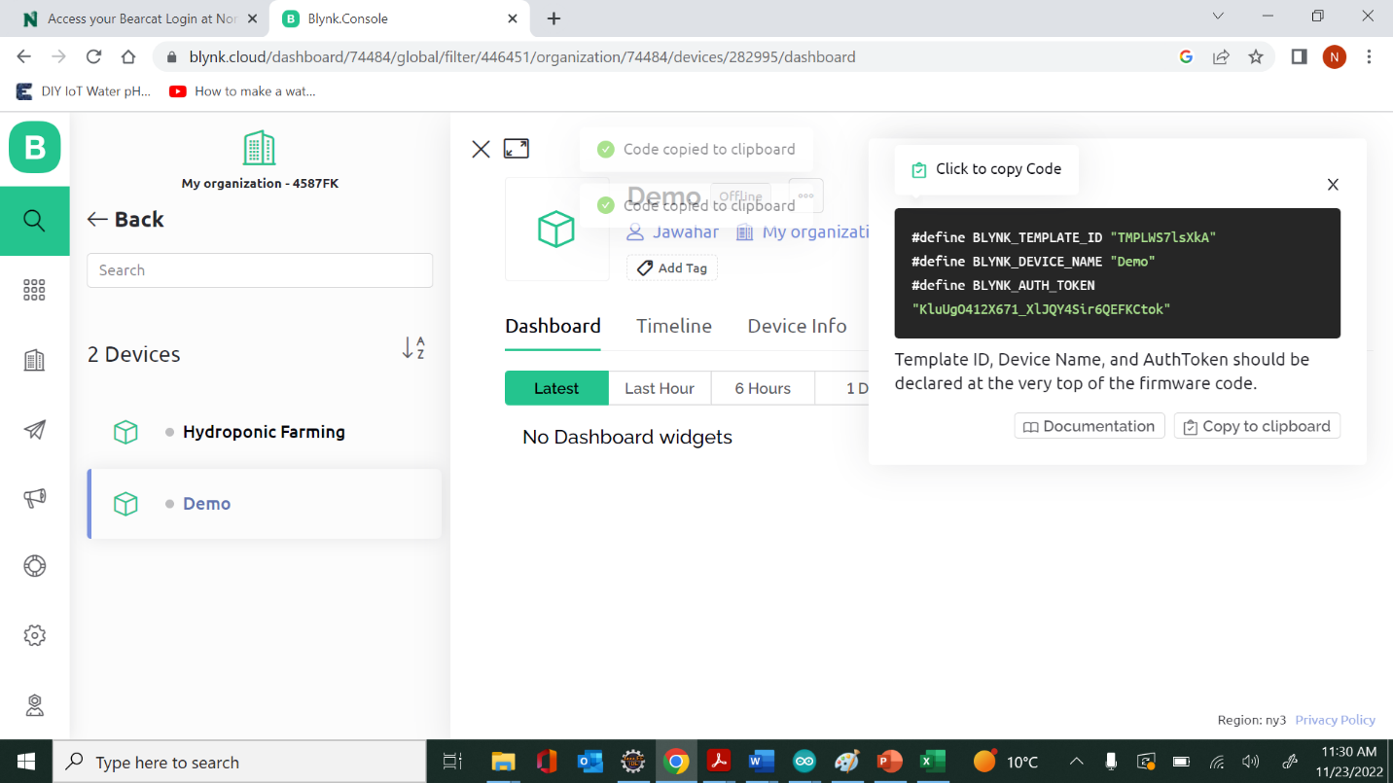

  - Functional Requirements:
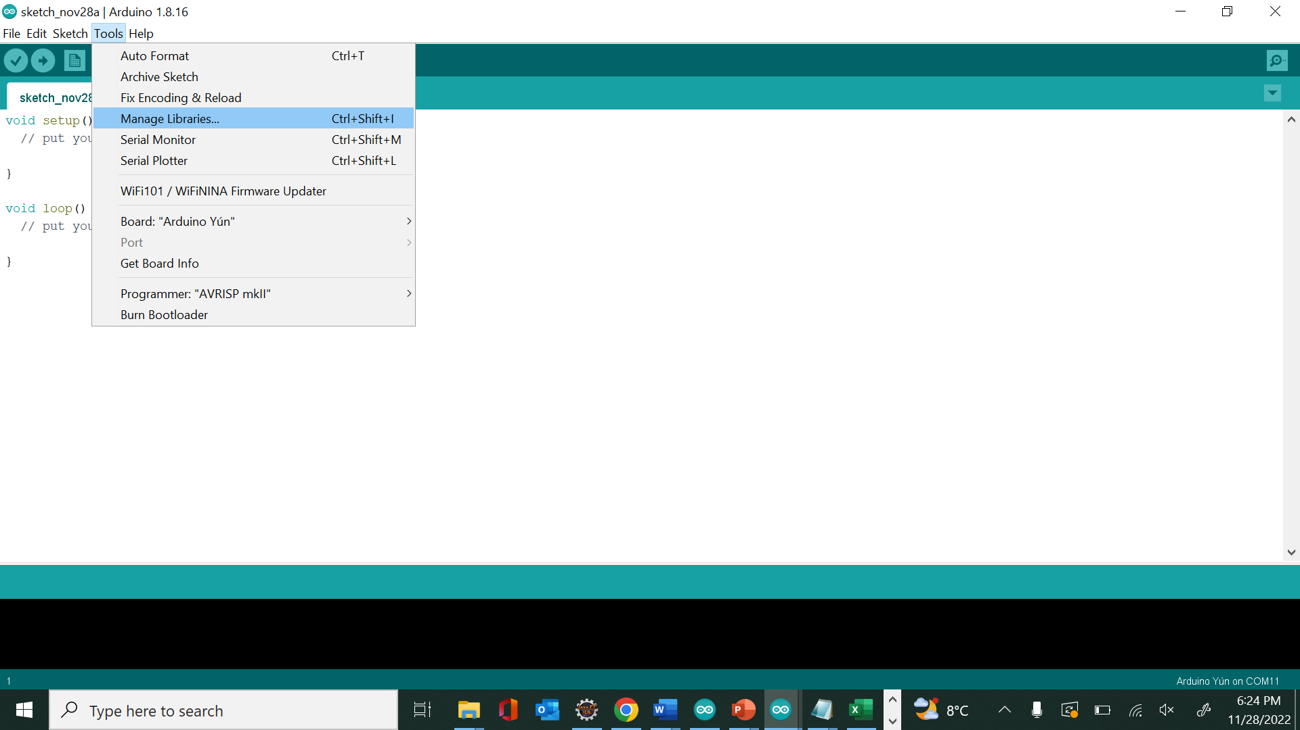
In Manage libraries menu we have to add some external libraries for DS18B20, DHT11, pH sensor thar are <DHT.h>, <OneWire.h>, <DallasTemperature.h>

  - Methods

- digitalWrite is used to turn on/off device.
- Blynk.virtualWrite: Virtual Pins are commonly used to interface with other libraries (Servo, LCD and others) and implement custom logic. The device can send data to the App using Blynk.virtualWrite(pin, value) and receive data from the App using BLYNK_WRITE (vPIN)
- Serial.println is used to print on the console.

  - Non-Functional Requirement
    - Performance: In terms of performance, Esp32 is faster and is available in a dual-core design. It is also capable of operating in an ultra-low-power mode, ideal for battery-powered applications
    - Reliability: Sensors that are used in this project are very accurate as we are having GPIO pins which are of 12 bits. So, data gathered from the sensors are very accurate.
    - Availability: Both Arduino IDE and Blynk IOT are open-source platforms available for free.
    - Security: In terms of security Blynk IOT provides an authorization token to connect the microcontroller to the Blynk IOT platform.
    - Portability: Blynk IOT can be opened in multiple devices to monitor and get the notification alerts.
    - Design Constraints: To make system work power supply and Wi-Fi is mandatory
- DHT11: power supply range: 3-5.5V.
- DS18B20: power supply range: 3-5V.
- HCSR04: Operating voltage: 3.3v - 5V.
- pH sensor: Module Power- DC 9.00V 1A.
- MQ135: Operating Voltage-2.5V to 5.0V.

  - Prototypes 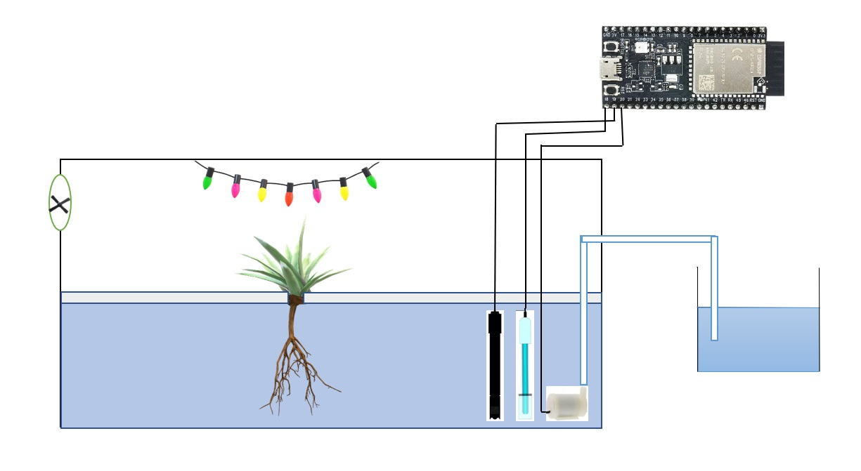
This is our prototype like how the Smart Hydroponic Farming is implemented where we have sensors to measure temperature of water and pH of water. So whenever the water conditions change we change the water inside the aquarium.

- Design:

4.1. Block diagram
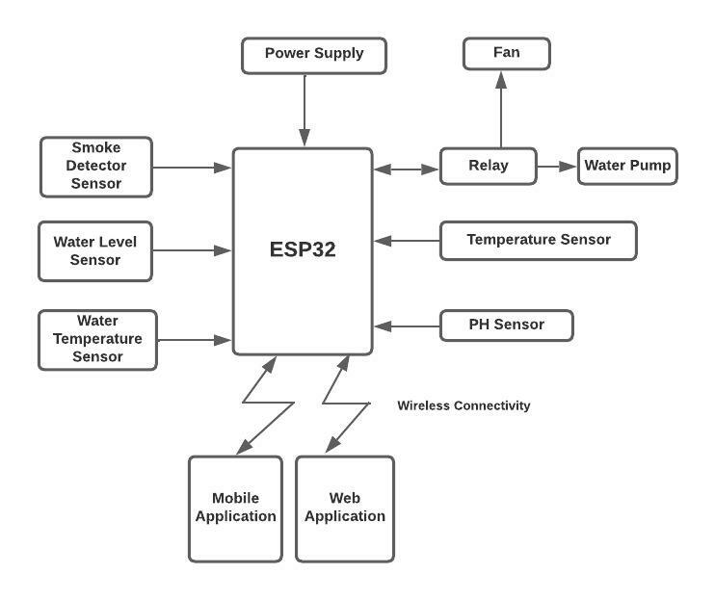
The proposed system includes a variety of sensors such as pH sensor to monitor the pH level inside the water, DHT11 Temperature sensor to detect the temperature and Humidity of the Environment, DS18B20 to detect the water temperature. This system also consists of the relay which is used for controlling the water pump to maintain water level inside the tank and HCSR04 sensor to detect the water level inside the tank. The microcontroller that serves as the heart of the system is ESP32. To monitor and control the sensor readings Blynk IoT application is used. Block diagram of the proposed system is shown in figure.

4.2. GUI
The sensor values are displayed on the Blynk IoT platform, and we can get the notification alerts when the environmental parameters exceed the expected values.

5. Analysis Models
5.1 Flow Diagram
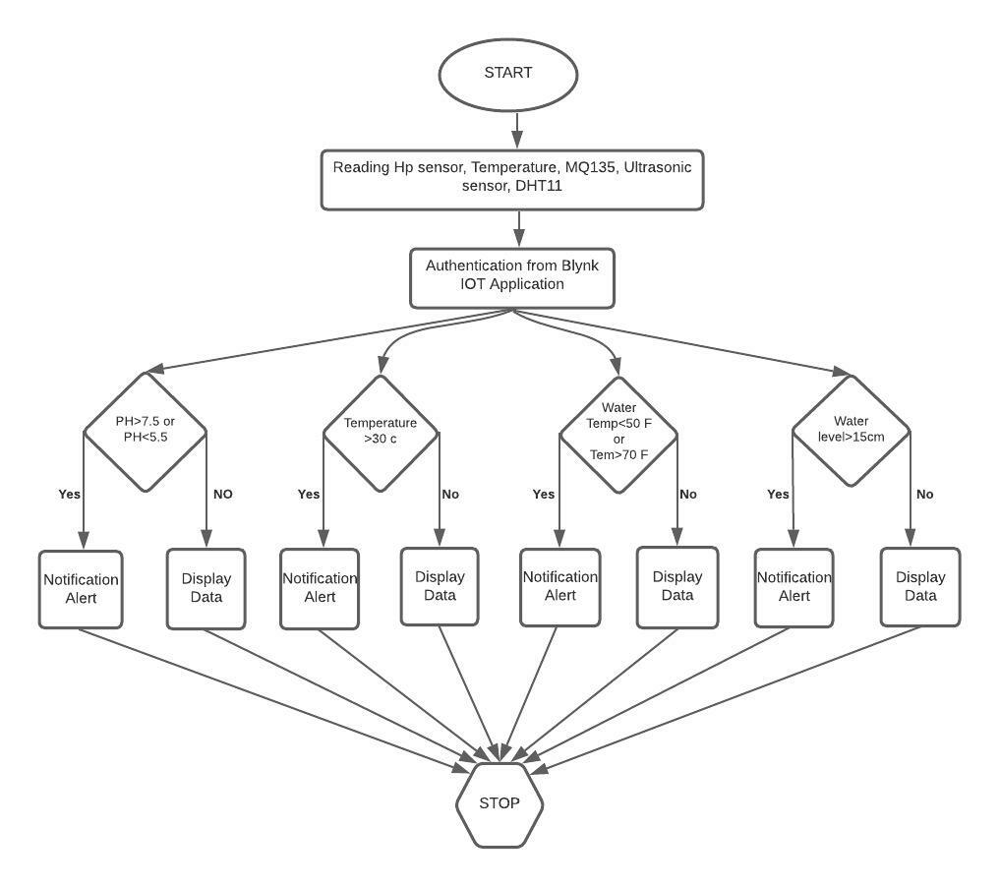
The system begins to read the pH, temperature, liquid solution temperature, and tank water level readings. When the threshold value is exceeded, Blynk IoT sends the user a notification alert or displays the data. If pH value >7.5 or pH <5.5, water temperature > 70 or water temperature < 50, temperature> 30c, water level >15cm, Notification alerts are sent to the user. According to the input of pH, water temperature, and water level inside the tank, the rules are set to manage the motor condition.

